# Lab 4 – Windows Command Line

## 1.0 Working from the Command Line (Complete on Server1)

1. Logon to your server as the Administrator and open a Command Prompt Window.
2. Change your directory to the root of C: and create the following directory structure using the Command Line Interface (CLI). Where the directory structure says SenecaID, use your SenecaID.

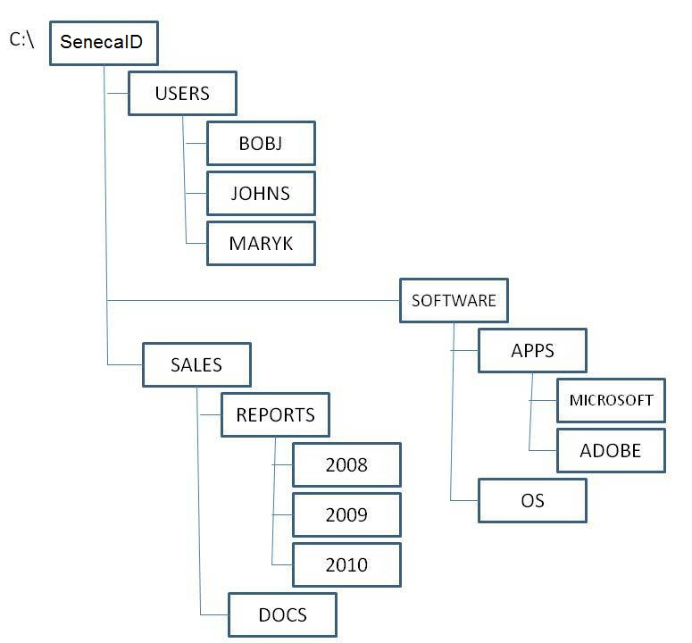

When the directory structure is complete:

1. Create a text file named file1.txt in the 2008 directory. Write the command you used.
2. Create a text file named file2.txt in the ADOBE directory. Write the command you used.
3. Create a text file named file3.txt in the MARYK directory. Write the command you used.

At the end of the lab you will be required to show the directory structure and files you created to your instructor and show the completed Paths exercise below. If you created the directory structure on a computer outside of the lab room (or not on a laptop that you can bring to the lab room), use the tree /f command to display the directory structure you created and take a screen shot of the output to display to your instructor.

**How to create a “screen shot”. Do this from the HOST operating system, not from inside the server:  
<https://support.microsoft.com/en-ca/help/4027213/windows-10-open-snipping-tool-and-take-a-screenshot>

## 2.0 Absolute and Relative Paths

Using the directory structure you created above, write a single line command to accomplish each task.

In the **A**field, use an ABSOLUTE path. In the **R** field, use a RELATIVE path. Answer each question and track the changes that are made on the directory structure, removing directories and files that are removed and adding the ones that are created. You do NOT need to make the changes to the directory structure on the computer.

1.       You are in the USERS directory. Move file3.txt to the JOHNS directory and rename it file4.txt.

A

R

2.       You are in the SALES directory. Create a new file called January.txt in 2009.

A

R

3.       You are in the SOFTWARE directory. Create a new directory called SUN under OS.

A

R

4.       You are in the ADOBE directory. Change to the SUN directory.

A

R

5.       You are in the SUN directory. Delete the MICROSOFT directory.

A

R

6.       You are in the SUN directory. Copy file4.txt to the DOCS directory.

A

R

7.       You are in the SenecaID directory. Delete the 2008 directory.

A

R

8.       You are in the JOHNS directory. Delete file4.txt that is in the JOHNS directory.

A

R

9.       You are in the USERS directory. Create a directory listing of REPORTS, showing all files, organized by date.

A

R

10.   You are in the ROOT directory. Create a graphical display of the SALES directory structure, including files and put the data from that command into a file called MYDIRLIST.txt in the BOBJ directory.

A

R

11.   You are in the BOBJ directory. Display the contents of MYDIRLIST.txt to the screen.

A

R

**To prove you have completed this lab:**

* **Create a Microsoft Word document (or use Google docs), with a name of *YourSenecaID*-Lab4.docx.**
* **Copy and paste the answers from the Absolute and Relative path questions into the Word doc.**
* **use a command to display your directory structure at the command line, showing files and take a screen shot and paste it into the Word document with your questions and answers.**

**Save the document as a PDF file (or Print as PDF) using the same name as the document file and upload it to Learn@Seneca. You will find the link in the Weekly Module on Learn@Seneca.**